**Name:** Nishan Paul

**ID:** 1604085

**Course Title:** Computer Graphics (Sessional)

**Course No:** CSE-458

**Level 4, Term 1**

**Assignment 08**

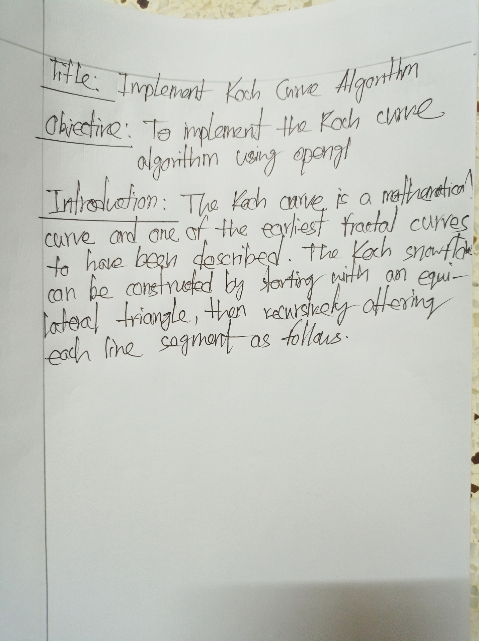

**Code:**

#include<windows.h>

#include<GL/glut.h>

#include<bits/stdc++.h>

using namespace std;

float cnst = 3.1416/180;

void pp(float x, float y, float width, float temp) {

float ee = temp*cnst;

glBegin(GL_LINES);

glVertex2f(x,y);

glVertex2f(x + width*cos(ee), y + width*sin(ee));

glEnd();

}

void algo(float x, float y, float width, float temp, int n) {

if (n > 0) {

width /= 3;

float ee = temp*cnst;

float ff = (temp - 60)*cnst;

float gg = (temp + 60)*cnst;

algo(x, y, width, temp, n - 1);

x = x + width*cos(ee);

y = y + width*sin(ee);

algo(x, y, width, temp - 60, n - 1);

x = x + width*cos(ff);

y = y + width*sin(ff);

algo(x, y, width, temp + 60, n - 1);

x = x + width*cos(gg);

y = y + width*sin(gg);

algo(x, y, width, temp, n - 1);

}

else

pp(x, y, width, temp);

glFlush();

}

void init(void) {

glClearColor(0,0,0,0);

glMatrixMode(GL_PROJECTION);

glLoadIdentity();

gluOrtho2D(-100, 100, -100, 100);

}

int main (int argc, char **argv)

{

glutInit(&argc, argv);

glutInitDisplayMode (GLUT_SINGLE | GLUT_RGB);

glutInitWindowSize(1000, 600);

glutInitWindowPosition(500, 300);

glutCreateWindow("1604085 / lab 8");

init();

glutDisplayFunc([]() {

algo(-30, -30, 80, 0, 1);

algo(50, -30, 80, 120, 1);

algo(10, 40, 80, 240, 1);

});

glutMainLoop();

return 0;

}

**Output:**



